Grand Luxxe Accommodations

First block:

Please darken & wider letters here too like the others we discussed

ROOMS & SUITES  
Grand Luxxe Two Bedroom Suites

This exclusive suite features a gourmet kitchen, a living room, two bedrooms, two and a half bathrooms with two Jacuzzi tubs and two private terraces and a plunge pool.

Click image to browse PHOTOS:

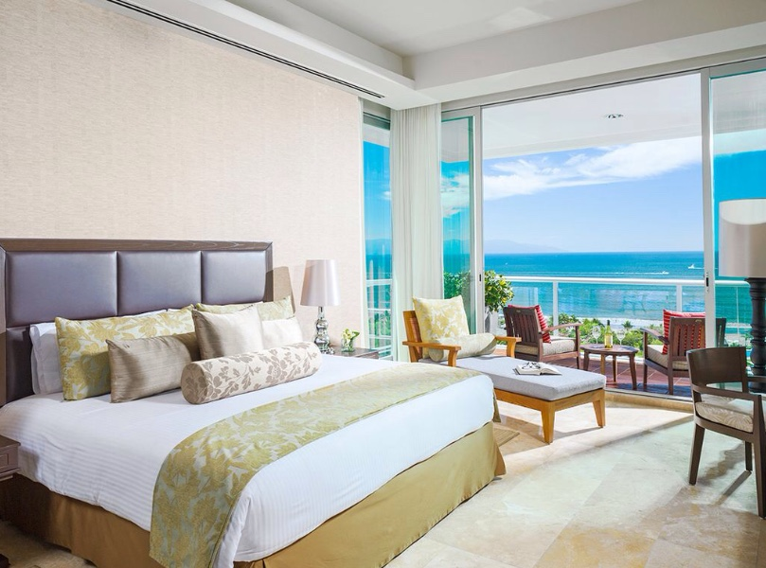

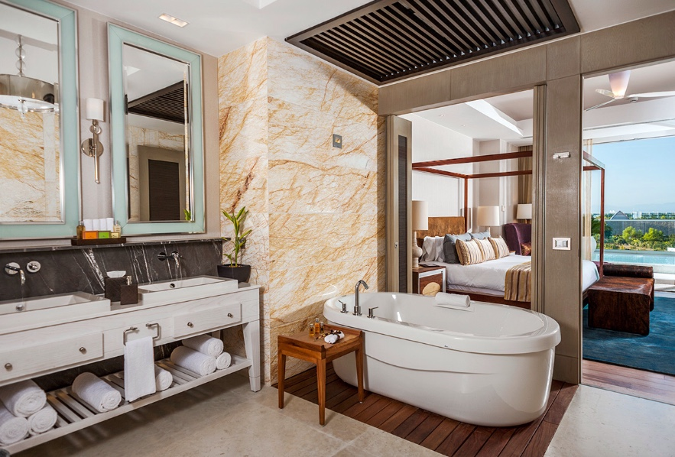

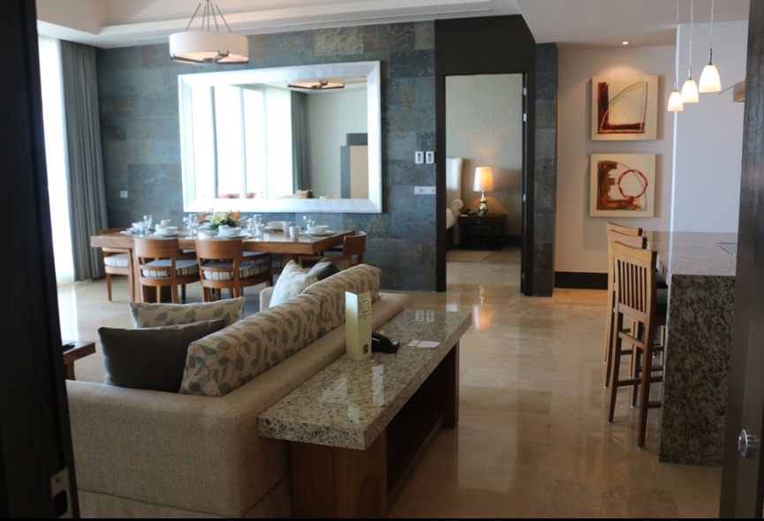

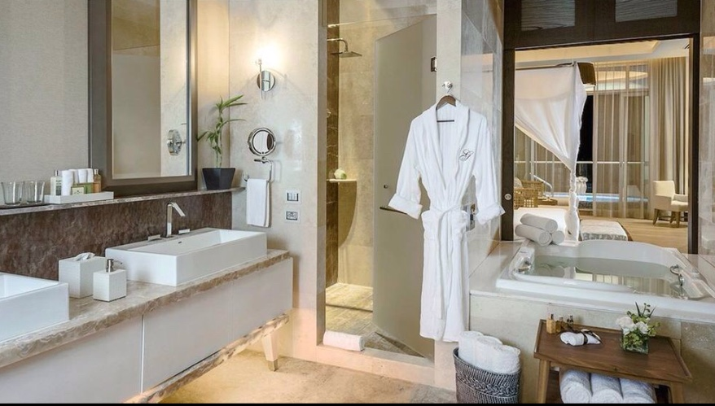

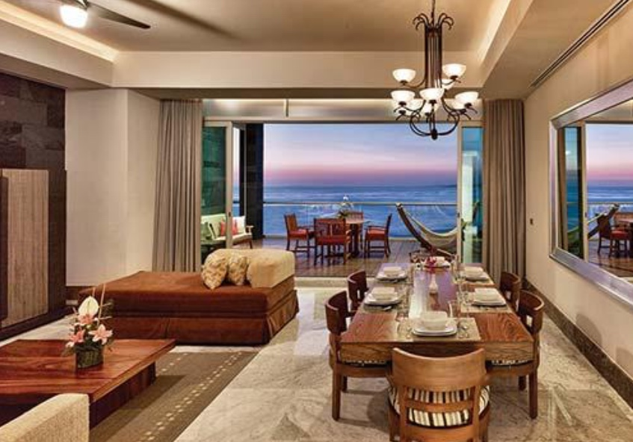

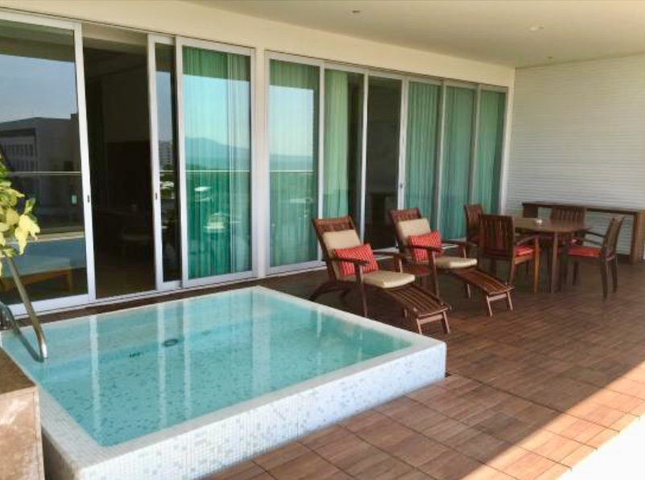

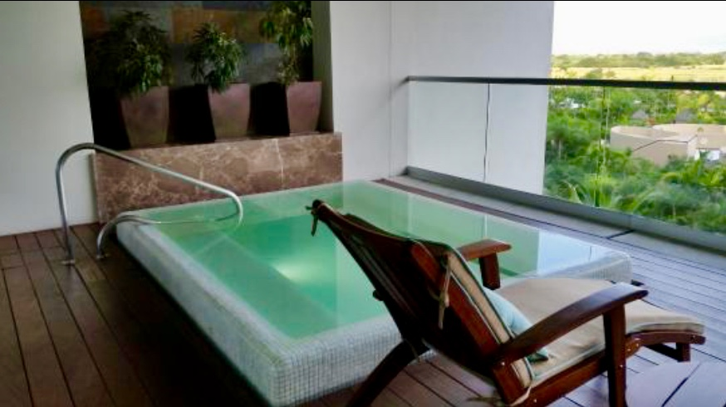

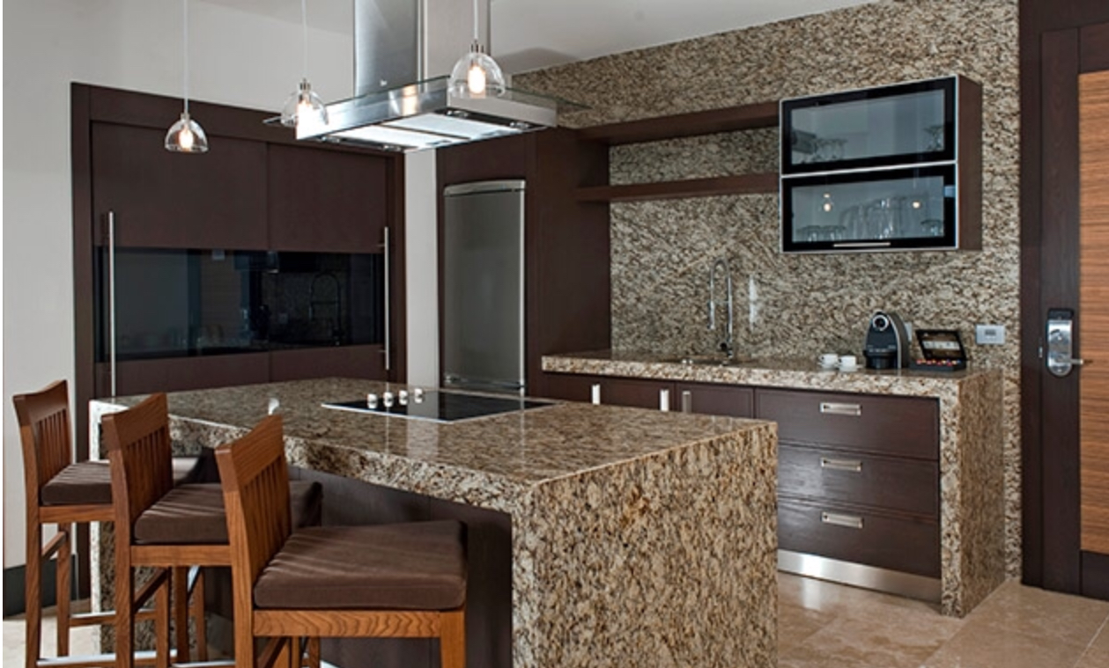

After clicking “Learn” button:

ROOMS & SUITES   
Grand Luxxe Two Bedroom Suite  
This elegant quarters is a two-bedroom, two-and-a-half bath suite of approximately 3,000 square feet, with two king-size beds or one king-size bed and two double beds, two and a half bathrooms with two Jacuzzi tubs, a relaxing terrace with a private plunge pool, master bedroom has a private terrace, gourmet kitchen, dining room, two living areas with sleeper sofas, and three 42" LED TVs. Accommodates 8 adults.

Under click through photos: Take off price

Occupancy: 8 adults, 2-4 kids depends on age/size

Type: Two Bedrooms

Bed: Two King-size Beds or One King-size Bed & Two Double Beds

Bathrooms: Two Full Bathrooms with Jacuzzi Tubs in each, 1 Half Bathroom

